**PROGRAM NO:01 DATE:10-08-2022**

**AIM:** Design a Login Form with username and password using LinearLayout and toast valid credentials.

**PROGRAM CODE:**

**activity.xml**

<?xml version="1.0" encoding="utf-8"?>

<LinearLayout xmlns:app="http://schemas.android.com/apk/res-auto"

xmlns:tools="http://schemas.android.com/tools"

xmlns:android="http://schemas.android.com/apk/res/android"

android:layout_width="match_parent"

android:layout_height="match_parent"

tools:context=".MainActivity"

android:orientation="vertical">

<TextView

android:layout_width="wrap_content"

android:layout_height="wrap_content"

android:text="LOGIN"

android:layout_marginTop="30dp"

/>

<EditText

android:layout_width="match_parent"

android:layout_height="wrap_content"

android:id="@+id/et1"

android:hint="Enter username"

/>

<EditText

android:layout_width="match_parent"

android:layout_height="wrap_content"

android:id="@+id/et2"

android:hint="Enter Password"

android:inputType="textPassword"

android:layout_marginTop="10dp"

/>

<Button

android:layout_width="wrap_content"

android:layout_height="wrap_content"

android:id="@+id/btn"

android:text="LOGIN"

android:layout_marginTop="20dp"

android:layout_marginStart="10dp"

android:layout_marginEnd="10dp"

/>

</LinearLayout>

**mainactivity.java**

package com.example.myapplication;

import androidx.appcompat.app.AppCompatActivity;

import android.os.Bundle;

import android.view.View;

import android.widget.Button;

import android.widget.EditText;

import android.widget.Toast;

public class MainActivity extends AppCompatActivity {

@Override

protected void onCreate(Bundle savedInstanceState) {

super.onCreate(savedInstanceState);

setContentView(R.layout.activity_main);

EditText et1=findViewById(R.id.et1);

EditText et2=findViewById(R.id.et2);

Button button=findViewById(R.id.btn);

button.setOnClickListener(new View.OnClickListener() {

@Override

public void onClick(View view) {

validate(et1.getText().toString(),et2.getText().toString());

}

private void validate(String us,String p)

{

if (us.equals("Admin")&&p.equals("1234")) {

Toast.makeText(getApplicationContext(), "Login successfull", Toast.LENGTH_LONG).show();

}

else

{

Toast.makeText(getApplicationContext(),"Unsuccessful",Toast.LENGTH_LONG).show( }

}

});

}

}

**RESULT:** Program compiled successfully and output verified.

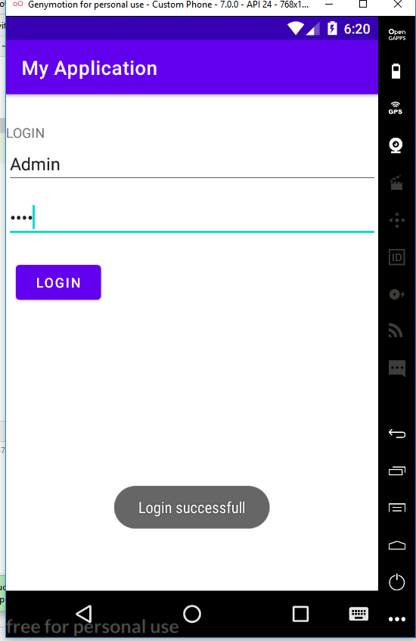**OUTPUT**

**PROGRAM NO:02 DATE:16-08-2022**

**AIM:** Write a program that demonstrates Activity Lifecycle.

**PROGRAM CODE:**

**activity.xml**

<?xml version="1.0" encoding="utf-8"?>

<androidx.constraintlayout.widget.ConstraintLayout xmlns:android="http://schemas.android.com/apk/res/android"

xmlns:app="http://schemas.android.com/apk/res-auto"

xmlns:tools="http://schemas.android.com/tools"

android:layout_width="match_parent"

android:layout_height="match_parent"

tools:context=".MainActivity">

<TextView

android:layout_width="wrap_content"

android:layout_height="wrap_content"

android:text="Hello World!"

app:layout_constraintBottom_toBottomOf="parent"

app:layout_constraintLeft_toLeftOf="parent"

app:layout_constraintRight_toRightOf="parent"

app:layout_constraintTop_toTopOf="parent" />

</androidx.constraintlayout.widget.ConstraintLayout>

**mainactivity.java**

package com.example.myapplication;

import androidx.appcompat.app.AppCompatActivity;

import android.os.Bundle;

import android.util.Log;

public class MainActivity extends AppCompatActivity {

@Override

protected void onCreate(Bundle savedInstanceState) {

super.onCreate(savedInstanceState);

setContentView(R.layout.activity_main);

Log.d("lifecycle","onCreate invoked");

}

@Override

protected void onStart()

{

super.onStart();

Log.d("lifecycle","onStart invoked");

}

@Override

protected void onResume()

{

super.onResume();

Log.d("lifecycle","onResume invoked");

}

@Override

protected void onPause()

{

super.onPause();

Log.d("lifecycle","onPause invoked");

}

@Override

protected void onStop()

{

super.onStop();

Log.d("lifecycle","onStop invoked");

}

@Override

protected void onRestart()

{

super.onRestart();

Log.d("lifecycle","onRetart invoked");

}

@Override

protected void onDestroy()

{

super.onDestroy();

Log.d("lifecycle","onDestroy invoked");

}

}

**RESULT:** Program compiled successfully and output verified.

**OUTPUT**

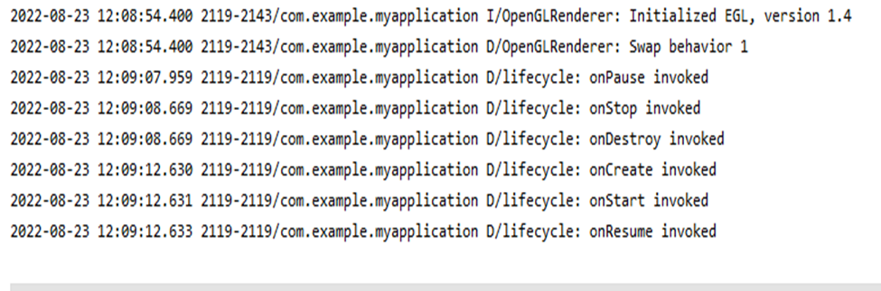

**PROGRAM NO:03 DATE:19-08-2022**

**AIM:** Implementing basic arithematic operations of a simple calculator.

**PROGRAM CODE:**

**activity.xml**

<?xml version="1.0" encoding="utf-8"?>

<LinearLayout xmlns:android="http://schemas.android.com/apk/res/android"

xmlns:app="http://schemas.android.com/apk/res-auto"

xmlns:tools="http://schemas.android.com/tools"

android:layout_width="match_parent"

android:layout_height="match_parent"

android:orientation="vertical"

tools:context=".MainActivity">

<TextView

android:layout_width="wrap_content"

android:layout_height="wrap_content"

android:text="Enter 1st num"

/>

<EditText

android:layout_width="wrap_content"

android:layout_height="wrap_content"

android:id="@+id/et1"

/>

<TextView

android:layout_width="wrap_content"

android:layout_height="wrap_content"

android:text="Enter 2nd num"

/>

<EditText

android:layout_width="wrap_content"

android:layout_height="wrap_content"

android:id="@+id/et2"

/>

<TextView

android:layout_width="wrap_content"

android:layout_height="wrap_content"

android:id="@+id/tv1"

/>

<Button

android:layout_width="wrap_content"

android:layout_height="wrap_content"

android:id="@+id/b1"

android:text="ADD"

/>

<Button

android:layout_width="wrap_content"

android:layout_height="wrap_content"

android:id="@+id/b2"

android:text="MUL"

/>

<Button

android:layout_width="wrap_content"

android:layout_height="wrap_content"

android:id="@+id/b3"

android:text="DIV"

/>

<Button

android:layout_width="wrap_content"

android:layout_height="wrap_content"

android:id="@+id/b4"

android:text="SUB"

/>

</LinearLayout>

**mainactivity.java**

package com.example.myapplication;

import androidx.appcompat.app.AppCompatActivity;

import android.os.Bundle;

import android.view.View;

import android.widget.Button;

import android.widget.EditText;

import android.widget.TextView;

public class MainActivity extends AppCompatActivity {

@Override

protected void onCreate(Bundle savedInstanceState) {

super.onCreate(savedInstanceState);

setContentView(R.layout.activity_main);

Button b1=findViewById(R.id.b1);

Button b2=findViewById(R.id.b2);

Button b3=findViewById(R.id.b3);

Button b4=findViewById(R.id.b4);

EditText et1=findViewById(R.id.et1);

EditText et2=findViewById(R.id.et2);

TextView tv1=findViewById(R.id.tv1);

b1.setOnClickListener(new View.OnClickListener() {

@Override

public void onClick(View view) {

Double a1=Double.parseDouble(et1.getText().toString());

Double a2=Double.parseDouble(et2.getText().toString());

Double r=a1+a2;

tv1.setText("Result is:" +String.valueOf(r));

}

});

b2.setOnClickListener(new View.OnClickListener() {

@Override

public void onClick(View view) {

Double a1=Double.parseDouble(et1.getText().toString());

Double a2=Double.parseDouble(et2.getText().toString());

Double r=a1*a2;

tv1.setText("Result is:" +String.valueOf(r));

}

});

b3.setOnClickListener(new View.OnClickListener() {

@Override

public void onClick(View view) {

Double a1=Double.parseDouble(et1.getText().toString());

Double a2=Double.parseDouble(et2.getText().toString());

Double r=a1/a2;

tv1.setText("Result is:" +String.valueOf(r));

}

});

b4.setOnClickListener(new View.OnClickListener() {

@Override

public void onClick(View view) {

Double a1=Double.parseDouble(et1.getText().toString());

Double a2=Double.parseDouble(et2.getText().toString());

Double r=a1-a2;

tv1.setText("Result is:" +String.valueOf(r));

}

});

}

}

**RESULT:** Program compiled successfully and output verified.

**OUTPUT**

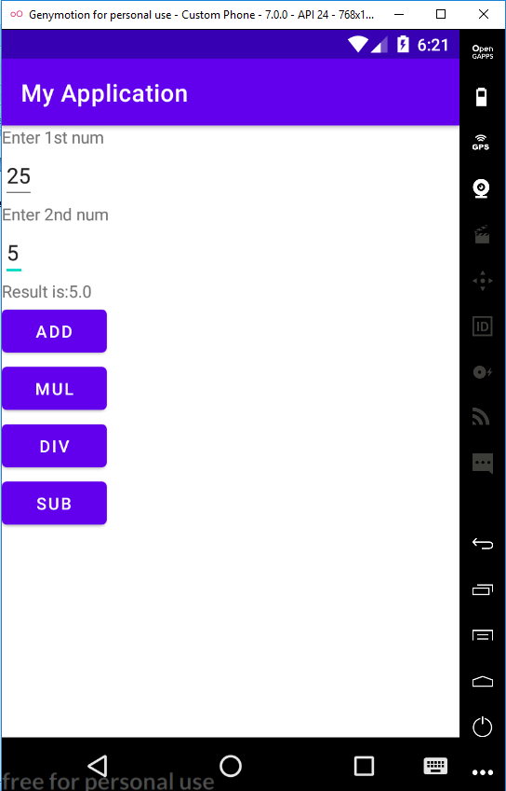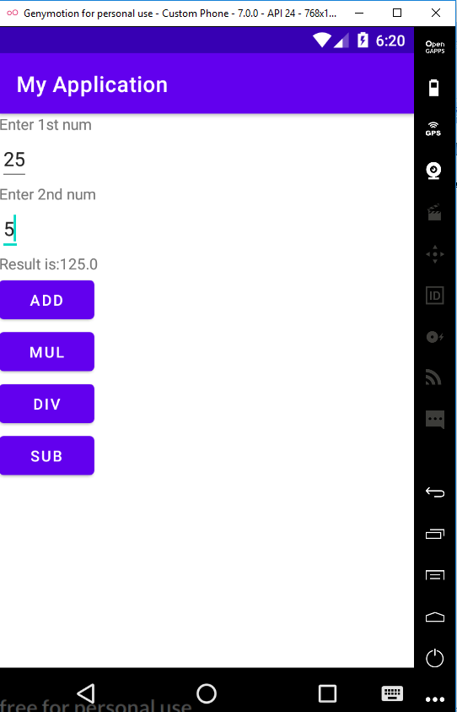

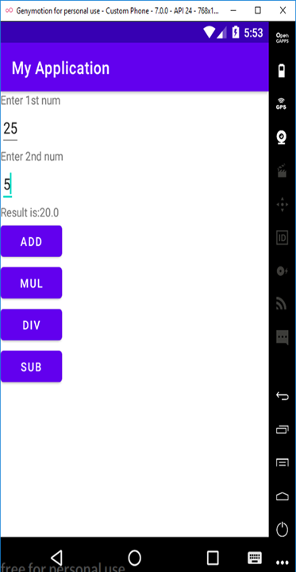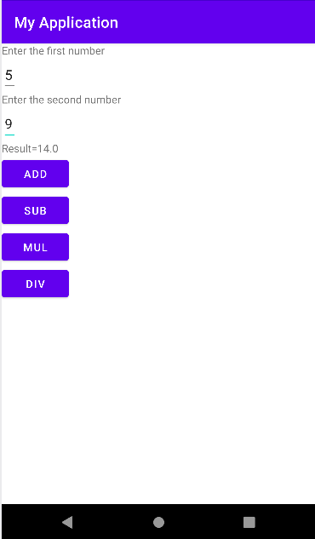

**PROGRAM NO:04 DATE:23-08-2022**

**AIM:** Implement validation on various UI controls

**PROGRAM CODE:**

**activity.Main**

<?xml version="1.0" encoding="utf-8"?>

<LinearLayout xmlns:android="http://schemas.android.com/apk/res/android"

xmlns:app="http://schemas.android.com/apk/res-auto"

xmlns:tools="http://schemas.android.com/tools"

android:layout_width="match_parent"

android:layout_height="match_parent"

android:orientation="vertical"

tools:context=".MainActivity">

<TextView

android:layout_width="wrap_content"

android:layout_height="wrap_content"

android:text="Registration"

android:textSize="3dp" />

<EditText

android:layout_width="match_parent"

android:layout_height="wrap_content"

android:hint="Name"

android:id="@+id/name"

/>

<EditText

android:layout_width="match_parent"

android:layout_height="wrap_content"

android:hint="Mobile No:"

android:id="@+id/mno"/>

<EditText

android:layout_width="match_parent"

android:layout_height="wrap_content"

android:hint="Age"

android:id="@+id/age"/>

<TextView

android:layout_width="wrap_content"

android:layout_height="wrap_content"

android:hint="Gender"

android:textSize="20dp"/>

<RadioGroup

android:layout_width="wrap_content"

android:layout_height="wrap_content"

android:id="@+id/rd">

<RadioButton

android:layout_width="wrap_content"

android:layout_height="wrap_content"

android:id="@+id/rd1"

android:text="Male"/>

<RadioButton

android:layout_width="wrap_content"

android:layout_height="wrap_content"

android:id="@+id/rd2"

android:text="Female"/>

</RadioGroup>

<Button

android:layout_width="wrap_content"

android:layout_height="wrap_content"

android:id="@+id/btn"

android:text="Submit"/>

<CheckBox

android:layout_width="wrap_content"

android:layout_height="wrap_content"

android:text="I agree all terms and conditions"

android:id="@+id/cb"/>

</LinearLayout>

**mainactivity.java**

package com.example.validation;

import androidx.appcompat.app.AppCompatActivity;

import android.content.Intent;

import android.os.Bundle;

import android.view.View;

import android.widget.Button;

import android.widget.CheckBox;

import android.widget.EditText;

import android.widget.RadioButton;

import android.widget.RadioGroup;

import android.widget.Toast;

public class MainActivity extends AppCompatActivity {

EditText name;

EditText mno;

EditText age;

RadioGroup radioGroup;

RadioButton male;

RadioButton female;

CheckBox checkBox;

Button button;

@Override

protected void onCreate(Bundle savedInstanceState) {

super.onCreate(savedInstanceState);

setContentView(R.layout.activity_main);

name=findViewById(R.id.name);

mno=findViewById(R.id.mno);

age=findViewById(R.id.age);

radioGroup=findViewById(R.id.rd);

male=findViewById(R.id.rd1);

female=findViewById(R.id.rd2);

checkBox=findViewById(R.id.cb);

button=findViewById(R.id.btn);

button.setOnClickListener(new View.OnClickListener() {

@Override

public void onClick(View view) {

if (error()){

Intent i=new Intent(MainActivity.this,Login.class);

startActivity(i);

}

}

});

}

private boolean error(){

if (name.getText().toString().length()==0){

Toast.makeText(getApplicationContext(), "please enter name",Toast.LENGTH_LONG).show();

return false;

}else if (mno .getText().toString().length()==0){

Toast.makeText(getApplicationContext(), "please enter mobile number",Toast.LENGTH_LONG).show();

return false;

}else if (mno.getText().toString().length()!=10){

Toast.makeText(getApplicationContext(), "please enter 10 number",Toast.LENGTH_LONG).show();

return false;

}else if (!male.isChecked()&& ! female.isChecked()){

Toast.makeText(getApplicationContext(), "please choose radio button",Toast.LENGTH_LONG).show();

return false;

}else if(!checkBox.isChecked()){

Toast.makeText(getApplicationContext(), "please click on checkbox",Toast.LENGTH_LONG).show();

return false;

}else {

return true;

}

}

}

**activity_login.xml**

<?xml version="1.0" encoding="utf-8"?>

<androidx.constraintlayout.widget.ConstraintLayout xmlns:android="http://schemas.android.com/apk/res/android"

xmlns:app="http://schemas.android.com/apk/res-auto"

xmlns:tools="http://schemas.android.com/tools"

android:layout_width="match_parent"

android:layout_height="match_parent"

tools:context=".Login">

<TextView

android:id="@+id/textView"

android:layout_width="wrap_content"

android:layout_height="wrap_content"

android:text="Welcome to login page"

tools:layout_editor_absoluteX="150dp"

tools:layout_editor_absoluteY="43dp" />

</androidx.constraintlayout.widget.ConstraintLayout>

**activity_login.java**

package com.example.validation;

import androidx.appcompat.app.AppCompatActivity;

import android.os.Bundle;

public class Login extends AppCompatActivity {

@Override

protected void onCreate(Bundle savedInstanceState) {

super.onCreate(savedInstanceState);

setContentView(R.layout.activity_login);

}

}

**RESULT:** Program compiled successfully and output verified.

**OUTPUT:**

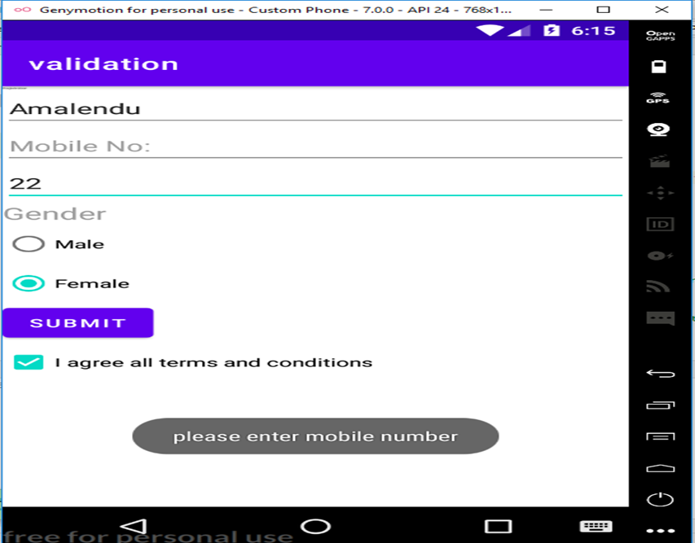

**PROGRAM NO:05 DATE:12-10-2022**

**AIM:** Design a registration activity and store registration details in local memory of phone using Intents and SharedPreferences.

**PROGRAM CODE:**

**activity.xml**

<?xml version="1.0" encoding="utf-8"?>

<RelativeLayout xmlns:android="http://schemas.android.com/apk/res/android"

xmlns:app="http://schemas.android.com/apk/res-auto"

xmlns:tools="http://schemas.android.com/tools"

android:layout_width="match_parent"

android:layout_height="match_parent"

android:orientation="vertical"

tools:context=".MainActivity">

<TextView

android:layout_width="wrap_content"

android:layout_height="wrap_content"

android:layout_centerHorizontal="true"

android:id="@+id/textview"

android:layout_marginTop="32dp"

android:text="Registration Form"

android:textSize="3dp" />

<EditText

android:layout_width="match_parent"

android:layout_height="wrap_content"

android:layout_below="@+id/textview"

android:layout_marginStart="16dp"

android:layout_marginTop="8dp"

android:layout_marginEnd="16dp"

android:hint="Enter your name"

android:id="@+id/name"

android:padding="10dp"

/>

<EditText

android:layout_width="match_parent"

android:layout_height="wrap_content"

android:layout_below="@+id/name"

android:layout_marginStart="16dp"

android:layout_marginTop="8dp"

android:layout_marginEnd="16dp"

android:hint="Enter your age"

android:padding="10dp"

android:id="@+id/age"/>

<EditText

android:layout_width="match_parent"

android:layout_height="wrap_content"

android:layout_below="@+id/age"

android:layout_marginStart="16dp"

android:layout_marginTop="8dp"

android:layout_marginEnd="16dp"

android:hint="Enter your email id"

android:padding="10dp"

android:id="@+id/email"/>

<EditText

android:layout_width="match_parent"

android:layout_height="wrap_content"

android:layout_below="@+id/email"

android:layout_marginStart="16dp"

android:layout_marginTop="8dp"

android:layout_marginEnd="16dp"

android:hint="Enter your address"

android:padding="10dp"

android:id="@+id/address"/>

<EditText

android:layout_width="match_parent"

android:layout_height="wrap_content"

android:layout_below="@+id/address"

android:layout_marginStart="16dp"

android:layout_marginTop="8dp"

android:layout_marginEnd="16dp"

android:hint="Enter your gender"

android:padding="10dp"

android:id="@+id/gender"/>

<EditText

android:layout_width="match_parent"

android:layout_height="wrap_content"

android:layout_below="@+id/gender"

android:layout_marginStart="16dp"

android:layout_marginTop="8dp"

android:layout_marginEnd="16dp"

android:hint="Enter your qualification"

android:padding="10dp"

android:id="@+id/quali"/>

<Button

android:layout_width="wrap_content"

android:layout_height="wrap_content"

android:id="@+id/btn"

android:layout_below="@id/quali"

android:text="Submit"/>

</RelativeLayout>

**mainActivity.java**

package com.example.myapplication;

import androidx.appcompat.app.AppCompatActivity;

import android.content.Intent;

import android.content.SharedPreferences;

import android.os.Bundle;

import android.view.View;

import android.widget.Button;

import android.widget.EditText;

public class MainActivity extends AppCompatActivity {

private EditText name, age,email,address,gender,quali;

Button btn;

@Override

protected void onCreate(Bundle savedInstanceState) {

super.onCreate(savedInstanceState);

setContentView(R.layout.activity_main);

name=findViewById(R.id.name);

age=findViewById(R.id.age);

email=findViewById(R.id.email);

address=findViewById(R.id.address);

gender=findViewById(R.id.gender);

quali=findViewById(R.id.quali);

btn=findViewById(R.id.btn);

btn.setOnClickListener(new View.OnClickListener()

{

@Override

public void onClick(View view){

Intent i= new Intent(MainActivity.this,MainActivity2.class);

startActivity(i);

}

});

}

@Override

protected void onResume(){

super.onResume();

SharedPreferences sh =getSharedPreferences("MySharedPref",MODE_PRIVATE);

String s1=sh.getString("name", "");

int a=sh.getInt("age",0);

String s2=sh.getString("email","");

String s3=sh.getString("address","");

String s4=sh.getString("gender","");

String s5=sh.getString("quali","");

name.setText(s1);

age.setText(String.valueOf(a));

email.setText(s2);

address.setText(s3);

gender.setText(s4);

quali.setText(s5);

}

@Override

protected void onPause(){

super.onPause();

SharedPreferences sharedPreferences=getSharedPreferences("MySharedPref",MODE_PRIVATE);

SharedPreferences.Editor myEdit=sharedPreferences.edit();

myEdit.putString("name",name.getText().toString());

myEdit.putInt("age",Integer.parseInt(age.getText().toString()));

myEdit.putString("email",email.getText().toString());

myEdit.putString("address",address.getText().toString());

myEdit.putString("gender",gender.getText().toString());

myEdit.putString("quali",quali.getText().toString());

myEdit.commit();

}

}

**activity2.xml**

<?xml version="1.0" encoding="utf-8"?>

<RelativeLayout xmlns:android="http://schemas.android.com/apk/res/android"

xmlns:app="http://schemas.android.com/apk/res-auto"

xmlns:tools="http://schemas.android.com/tools"

android:layout_width="match_parent"

android:layout_height="match_parent"

tools:context=".MainActivity2">

<TextView

android:layout_width="wrap_content"

android:id="@+id/textview"

android:layout_centerHorizontal="true"

android:text="Welcome"/>

</RelativeLayout>

**mainactivity2.java**

package com.example.myapplication;

import androidx.appcompat.app.AppCompatActivity;

import android.os.Bundle;

public class MainActivity2 extends AppCompatActivity {

@Override

protected void onCreate(Bundle savedInstanceState) {

super.onCreate(savedInstanceState);

setContentView(R.layout.activity_main2);

}

}

**RESULT:** Program compiled successfully and output verified.

**OUTPUT**

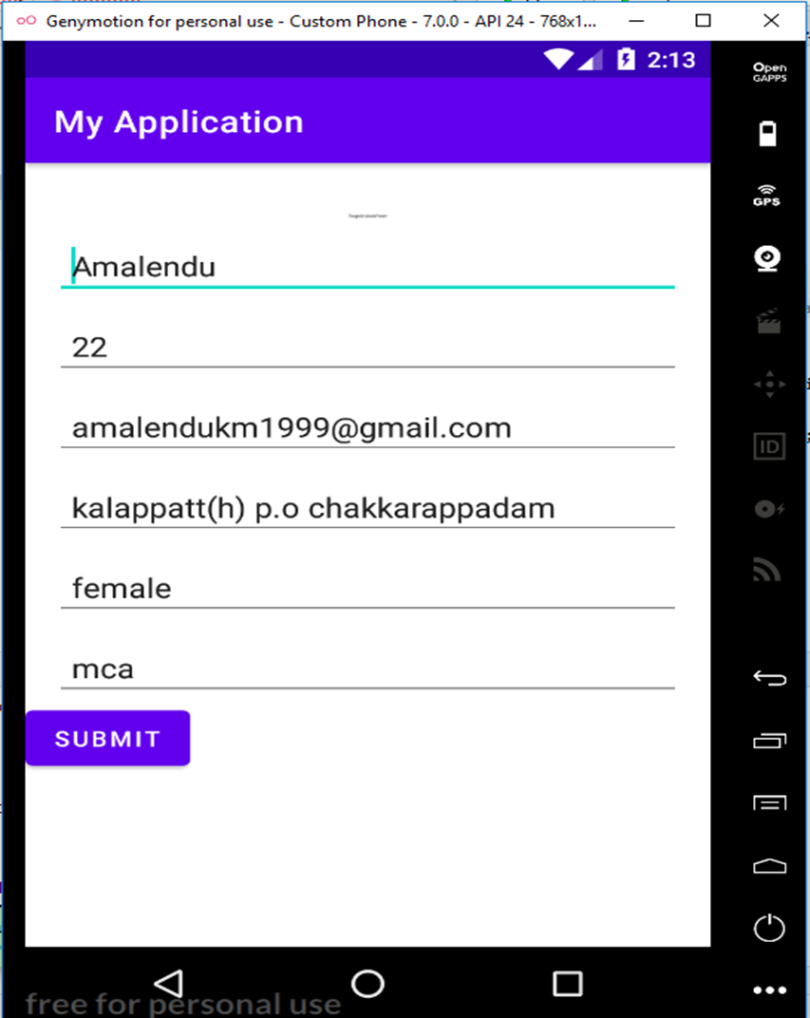

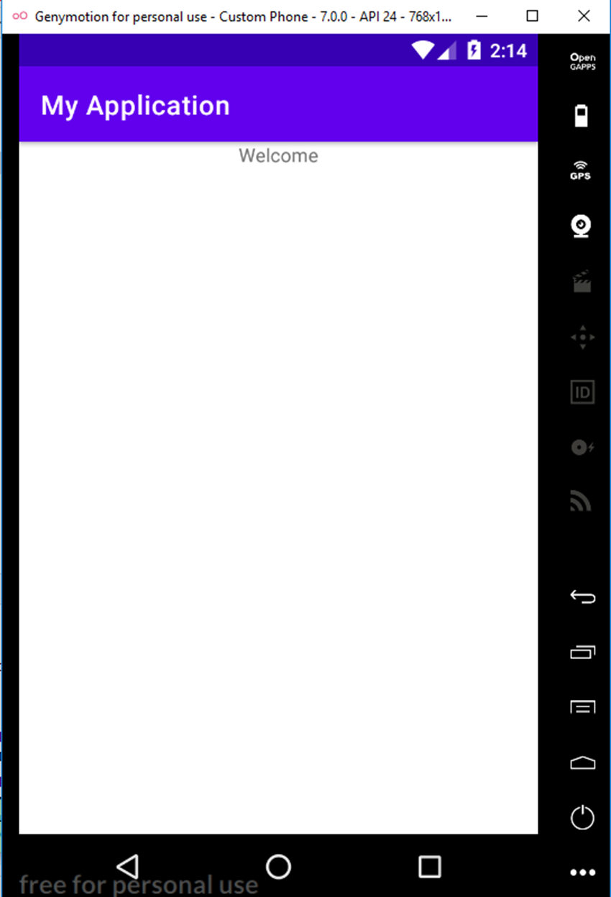

**PROGRAM NO:06 DATE:25-10-2022**

**AIM:** Design a simple Calculator using GridLayout.

**PROGRAM CODE:**

**activity.xml**

<?xml version="1.0" encoding="utf-8"?>

<GridLayout xmlns:android="http://schemas.android.com/apk/res/android"

xmlns:app="http://schemas.android.com/apk/res-auto"

xmlns:tools="http://schemas.android.com/tools"

android:layout_width="match_parent"

android:layout_height="match_parent"

tools:context=".MainActivity">

<TextView

android:layout_width="wrap_content"

android:layout_height="wrap_content"

android:text="Enter 1st num"

android:layout_row="0"

android:layout_column="0"/>

<EditText

android:layout_width="wrap_content"

android:layout_height="wrap_content"

android:id="@+id/n1"

android:layout_row="1"

android:layout_column="0"/>

<TextView

android:layout_width="wrap_content"

android:layout_height="wrap_content"

android:text="Enter 1st num"

android:layout_row="2"

android:layout_column="0"/>

<EditText

android:layout_width="wrap_content"

android:layout_height="wrap_content"

android:id="@+id/n2"

android:layout_row="3"

android:layout_column="0"/>

<Button

android:text="ADD"

android:layout_width="wrap_content"

android:layout_height="wrap_content"

android:layout_row="4"

android:layout_column="2"

android:textColor="@color/white"

android:background="@color/design_default_color_error"

android:id="@+id/add"/>

<Button

android:text="MUL"

android:layout_width="wrap_content"

android:layout_height="wrap_content"

android:layout_row="4"

android:layout_column="1"

android:textColor="@color/white"

android:background="@color/design_default_color_error"

android:id="@+id/mul"/>

<Button

android:text="SUB"

android:layout_width="wrap_content"

android:layout_height="wrap_content"

android:layout_row="4"

android:layout_column="0"

android:textColor="@color/white"

android:background="@color/design_default_color_error"

android:id="@+id/sub"/>

<Button

android:text="DIV"

android:layout_width="wrap_content"

android:layout_height="wrap_content"

android:layout_row="4"

android:layout_column="3"

android:textColor="@color/white"

android:background="@color/design_default_color_error"

android:id="@+id/div"/>

<TextView

android:hint="Result"

android:width="70dp"

android:height="50dp"

android:layout_row="2"

android:layout_column="2"

android:id="@+id/result"

android:textColor="@color/design_default_color_error"/>

</GridLayout>

**mainactivity.java**

package com.example.myapplication9;

import androidx.appcompat.app.AppCompatActivity;

import android.os.Bundle;

import android.view.View;

import android.widget.Button;

import android.widget.EditText;

import android.widget.TextView;

public class MainActivity extends AppCompatActivity {

@Override

protected void onCreate(Bundle savedInstanceState) {

super.onCreate(savedInstanceState);

setContentView(R.layout.activity_main);

EditText a = findViewById(R.id.n1);

EditText b = findViewById(R.id.n2);

Button add = findViewById(R.id.add);

Button mul = findViewById(R.id.mul);

Button sub = findViewById(R.id.sub);

Button div = findViewById(R.id.div);

TextView result = findViewById(R.id.result);

add.setOnClickListener(new View.OnClickListener() {

@Override

public void onClick(View view) {

Double n1 = Double.parseDouble(a.getText().toString());

Double n2 = Double.parseDouble(b.getText().toString());

Double r = n1 + n2;

result.setText(String.valueOf(r));

}

});

sub.setOnClickListener(new View.OnClickListener() {

@Override

public void onClick(View view) {

Double n1 = Double.parseDouble(a.getText().toString());

Double n2 = Double.parseDouble(b.getText().toString());

Double r = n1 - n2;

result.setText(String.valueOf(r));

}

});

mul.setOnClickListener(new View.OnClickListener() {

@Override

public void onClick(View view) {

Double n1 = Double.parseDouble(a.getText().toString());

Double n2 = Double.parseDouble(b.getText().toString());

Double r = n1 * n2;

result.setText(String.valueOf(r));

}

});

div.setOnClickListener(new View.OnClickListener() {

@Override

public void onClick(View view) {

Double n1 = Double.parseDouble(a.getText().toString());

Double n2 = Double.parseDouble(b.getText().toString());

Double r = n1 / n2;

result.setText(String.valueOf(r));

}

});

}

}

**RESULT:** Program compiled successfully and output verified.

**OUTPUT**

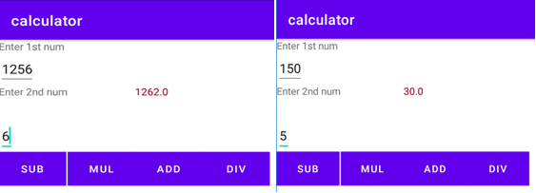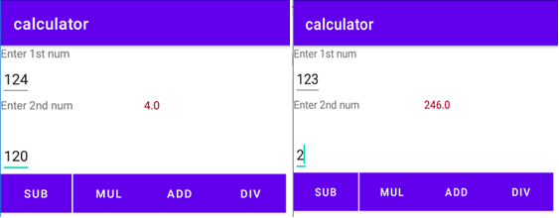

**PROGRAM NO:07**  **DATE:02-09-2022**

**AIM:** Create a Facebook page using RelativeLayout ; set properties using .xml file.

**PROGRAM CODE:**

**activity.xml**

<?xml version="1.0" encoding="utf-8"?>

<RelativeLayout

xmlns:android="http://schemas.android.com/apk/res/android"

xmlns:tools="http://schemas.android.com/tools"

android:id="@+id/activity_main"

android:layout_width="match_parent"

android:layout_height="match_parent"

tools:context=".MainActivity">

<RelativeLayout

android:id="@+id/relativeLayout"

android:layout_width="match_parent"

android:layout_height="wrap_content">

<ImageView

android:layout_width="match_parent"

android:layout_height="250dp"

android:id="@+id/banner"

android:src="@drawable/images2"

android:scaleType="centerCrop"/>

<ImageView

android:layout_marginLeft="15dp"

android:layout_width="100dp"

android:layout_height="150dp"

android:id="@+id/profilePic"

android:src="@drawable/images"

android:layout_alignBottom="@+id/linearLayout"/>

<LinearLayout

android:layout_toRightOf="@+id/profilePic"

android:layout_width="match_parent"

android:layout_height="wrap_content"

android:layout_below="@+id/banner"

android:orientation="horizontal"

android:weightSum="100"

android:id="@+id/linearLayout">

<Button

android:layout_width="wrap_content"

android:layout_height="wrap_content"

android:text="Timeline"

android:textSize="5dp"

android:layout_weight="10"/>

<Button

android:layout_weight="10"

android:textSize="5dp"

android:layout_width="wrap_content"

android:layout_height="wrap_content"

android:text="About"

/>

<Button

android:layout_weight="10"

android:textSize="5dp"

android:layout_width="wrap_content"

android:layout_height="wrap_content"

android:text="Friends"

/>

<Button

android:layout_weight="10"

android:textSize="5dp"

android:layout_width="wrap_content"

android:layout_height="wrap_content"

android:text="Photos"

/>

<Button

android:layout_weight="10"

android:textSize="5dp"

android:layout_width="wrap_content"

android:layout_height="wrap_content"

android:text="More"

/>

</LinearLayout>

<EditText

android:textColor="@color/white"

android:textStyle="bold"

android:layout_width="wrap_content"

android:layout_height="wrap_content"

android:inputType="textPersonName"

android:text="Amalendu"

android:ems="10"

android:layout_alignParentEnd="true"

android:layout_marginEnd="55dp"

android:id="@+id/textName"

android:layout_alignBottom="@+id/banner"/>

</RelativeLayout>

<RelativeLayout

android:paddingRight="15dp"

android:paddingLeft="15dp"

android:paddingTop="15dp"

android:paddingBottom="15dp"

android:layout_below="@+id/relativeLayout"

android:layout_width="match_parent"

android:layout_height="wrap_content">

<LinearLayout

android:layout_width="match_parent"

android:layout_height="wrap_content"

android:orientation="horizontal"

android:id="@+id/linearLayout2">

<ImageView

android:layout_marginLeft="5dp"

android:layout_marginTop="15dp"

android:layout_width="25dp"

android:layout_height="25dp"

android:src="@drawable/images2"/>

<EditText

android:id="@+id/etPost"

android:layout_marginLeft="10dp"

android:textSize="15sp"

android:layout_width="match_parent"

android:layout_height="60dp"

android:hint="What's on your mind?"/>

</LinearLayout>

<Button

android:textSize="10sp"

android:text="Post"

android:layout_width="70dp"

android:layout_height="30dp"

android:layout_alignParentRight="true"

android:layout_below="@+id/linearLayout2"/>

</RelativeLayout>

</RelativeLayout>

**RESULT:** Program compiled successfully and output verified.

**OUTPUT**

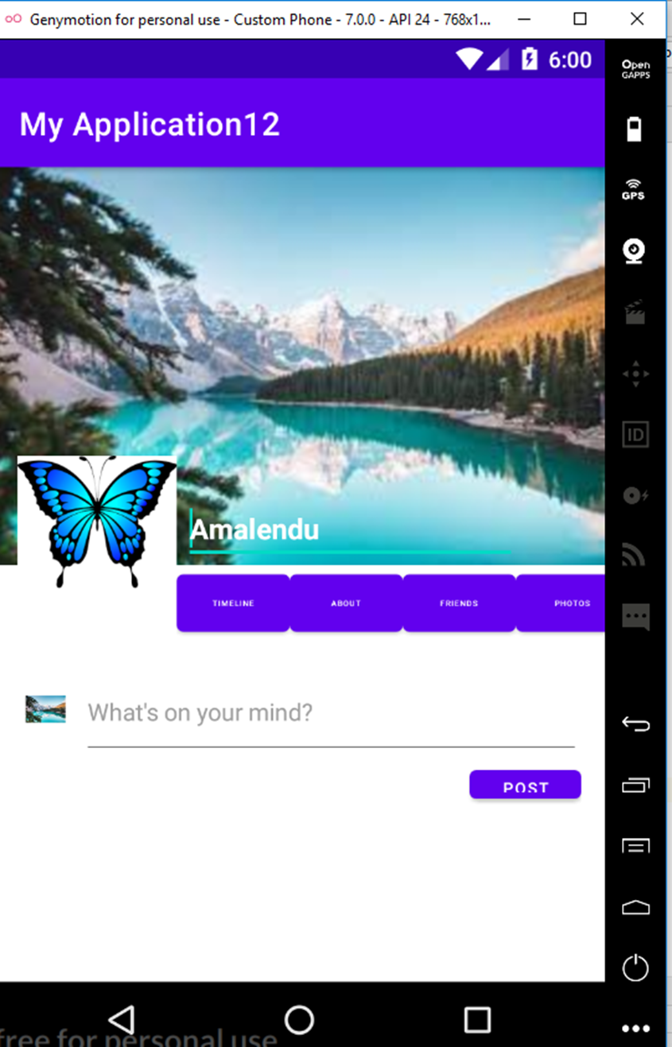

**PROGRAM NO:08** **DATE:14-09-2022**

**AIM:** Develop an application that toggles image using FrameLayout.

**PROGRAM CODE:**

**activity.xml**

<?xml version="1.0" encoding="utf-8"?>

<FrameLayout xmlns:android="http://schemas.android.com/apk/res/android"

xmlns:app="http://schemas.android.com/apk/res-auto"

android:id="@+id/frameLayout"

xmlns:tools="http://schemas.android.com/tools"

android:layout_width="match_parent"

android:layout_height="match_parent"

tools:context=".MainActivity">

<ImageView

android:id="@+id/image1"

android:layout_width="match_parent"

android:layout_height="239dp"

android:scaleType="centerCrop"

android:src="@drawable/image1" />

<ImageView

android:layout_width="match_parent"

android:layout_height="239dp"

android:scaleType="centerCrop"

android:src="@drawable/image2"

android:id="@+id/image2"/>

</FrameLayout>

Mainactivity.java

package com.example.myapplication11;

import androidx.appcompat.app.AppCompatActivity;

import android.os.Bundle;

import android.view.View;

import android.widget.ImageView;

public class MainActivity extends AppCompatActivity {

ImageView i1,i2;

@Override

protected void onCreate(Bundle savedInstanceState) {

super.onCreate(savedInstanceState);

setContentView(R.layout.activity_main);

i1=findViewById(R.id.image1);

i2=findViewById(R.id.image2);

i2.setOnClickListener(new View.OnClickListener() {

@Override

public void onClick(View view) {

i2.setVisibility(View.GONE);

i1.setVisibility(View.VISIBLE);

}

});

i1.setOnClickListener(new View.OnClickListener() {

@Override

public void onClick(View view) {

i1.setVisibility(View.GONE);

i2.setVisibility(View.VISIBLE);

}

});

}

}

**RESULT:** Program compiled successfully and output verified.

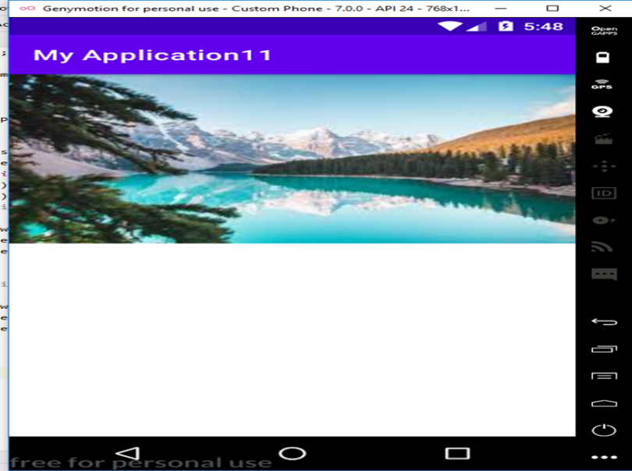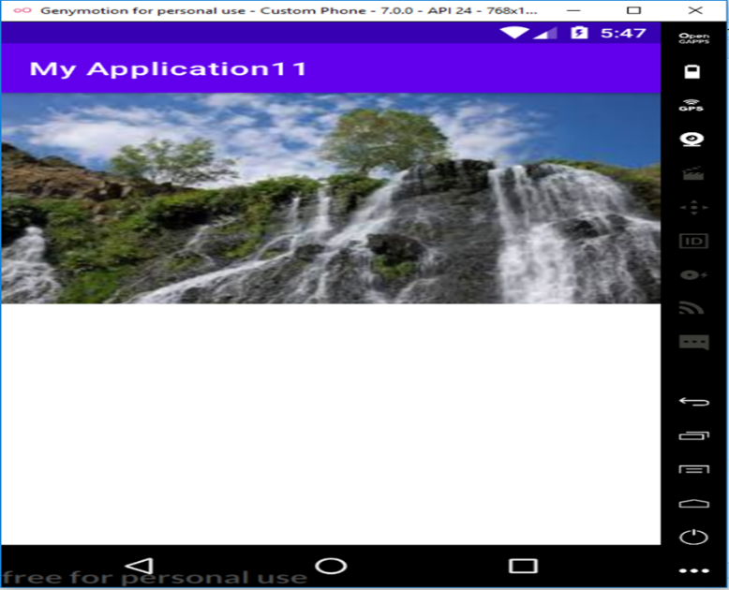**OUTPUT**

**PROGRAM NO:09** **DATE:16-09-2022**

**AIM:** Develop application that work with implement implicit intents.

**PROGRAM CODE:**

**activity.xml**

<?xml version="1.0" encoding="utf-8"?>

<LinearLayout xmlns:android="http://schemas.android.com/apk/res/android"

xmlns:app="http://schemas.android.com/apk/res-auto"

xmlns:tools="http://schemas.android.com/tools"

android:layout_width="match_parent"

android:layout_height="match_parent"

tools:context=".MainActivity">

<EditText

android:layout_width="wrap_content"

android:layout_height="wrap_content"

android:id="@+id/edt1"

android:text="http://www.google.co.in"

/>

<Button

android:id="@+id/bt1"

android:layout_width="wrap_content"

android:layout_height="wrap_content"

android:gravity="bottom"

android:text="CLICK" />

</LinearLayout>

**mainactivity.java**

package com.example.myapplication;

import androidx.appcompat.app.AppCompatActivity;

import android.content.Intent;

import android.net.Uri;

import android.os.Bundle;

import android.view.View;

import android.widget.Button;

import android.widget.EditText;

public class MainActivity extends AppCompatActivity {

EditText edt1;

Button b1;

@Override

protected void onCreate(Bundle savedInstanceState) {

super.onCreate(savedInstanceState);

setContentView(R.layout.activity_main);

edt1=findViewById(R.id.edt1);

b1=findViewById(R.id.bt1);

b1.setOnClickListener(new View.OnClickListener(){

@Override

public void onClick(View view){

String url=edt1.getText().toString();

Intent i= new Intent(Intent.ACTION_VIEW,Uri.parse(url));

startActivity(i);

}

});

}

}

**RESULT:** Program compiled successfully and output verified.

**OUTPUT**

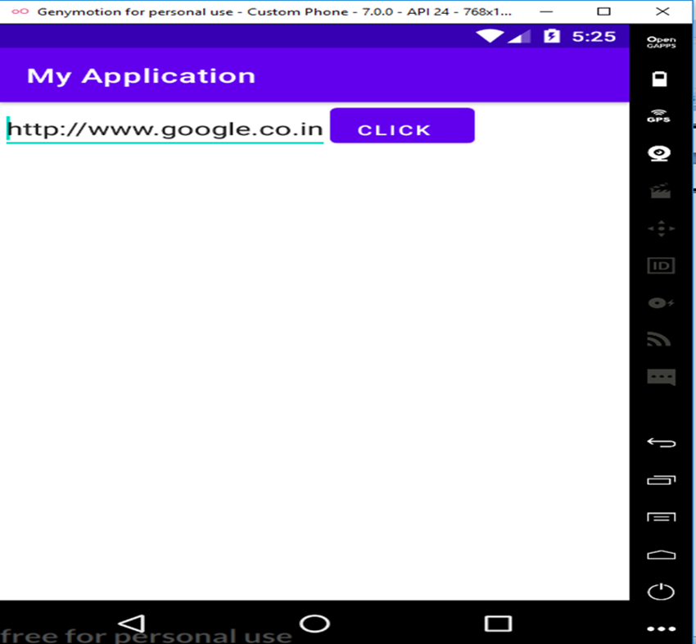

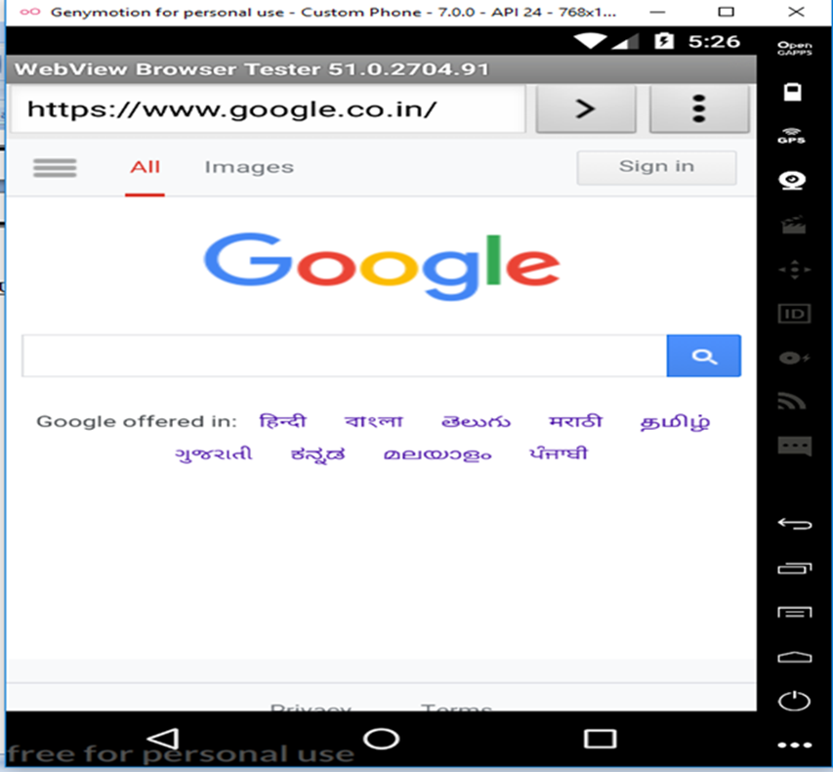

**PROGRAM NO:10** **DATE:20-09-2022**

**AIM:** Implement options menus to navigate 2 activities.

**PROGRAM CODE:**

**activity.xml**

<?xml version="1.0" encoding="utf-8"?>

<androidx.constraintlayout.widget.ConstraintLayout xmlns:android="http://schemas.android.com/apk/res/android"

xmlns:app="http://schemas.android.com/apk/res-auto"

xmlns:tools="http://schemas.android.com/tools"

android:layout_width="match_parent"

android:layout_height="match_parent"

tools:context=".MainActivity">

<TextView

android:layout_width="wrap_content"

android:layout_height="wrap_content"

android:text="Hello World!"

app:layout_constraintBottom_toBottomOf="parent"

app:layout_constraintLeft_toLeftOf="parent"

app:layout_constraintRight_toRightOf="parent"

app:layout_constraintTop_toTopOf="parent" />

</androidx.constraintlayout.widget.ConstraintLayout>

**menu.xml**

<?xml version="1.0" encoding="utf-8"?>

<menu xmlns:android="http://schemas.android.com/apk/res/android">

<item android:id="@+id/it1"

android:title="File"/>

<item android:id="@+id/it2"

android:title="Edit">

<menu>

<item android:id="@+id/subit1"

android:title="Copy"/>

<item android:id="@+id/subit2"

android:title="Cut"/>

<item android:id="@+id/subit3"

android:title="Paste"/>

</menu>

</item>

<item android:id="it3"

android:title="View"/>

</menu>

**mainactivity.java**

package com.example.myapplication8;

import androidx.annotation.NonNull;

import androidx.appcompat.app.AppCompatActivity;

import android.os.Bundle;

import android.view.Menu;

import android.view.MenuItem;

import android.widget.Toast;

public class MainActivity extends AppCompatActivity {

@Override

protected void onCreate(Bundle savedInstanceState) {

super.onCreate(savedInstanceState);

setContentView(R.layout.activity_main);

}

@Override

public boolean onCreateOptionsMenu(Menu menu) {

getMenuInflater().inflate(R.menu.menu,menu);

return true;

}

@Override

public boolean onOptionsItemSelected(@NonNull MenuItem item) {

switch(item.getItemId()){

case R.id.item1:

Toast.makeText(getApplicationContext(),"File selected",Toast.LENGTH_SHORT).show();

break;

case R.id.item2:

Toast.makeText(getApplicationContext(),"Edit selected",Toast.LENGTH_SHORT).show();

break;

case R.id.item3:

Toast.makeText(getApplicationContext(),"View selected",Toast.LENGTH_SHORT).show();

break;

case R.id.sitem1:

Toast.makeText(getApplicationContext(),"Cut selected",Toast.LENGTH_SHORT).show();

break;

case R.id.sitem2:

Toast.makeText(getApplicationContext(),"Copy selected",Toast.LENGTH_SHORT).show();

break;

case R.id.sitem3:

Toast.makeText(getApplicationContext(),"File selected",Toast.LENGTH_SHORT).show();

break;

}

return super.onOptionsItemSelected(item);

}

}

**RESULT:** Program compiled successfully and output verified.

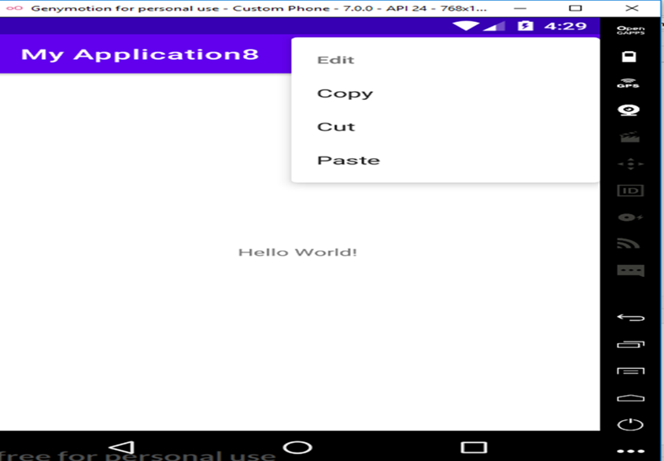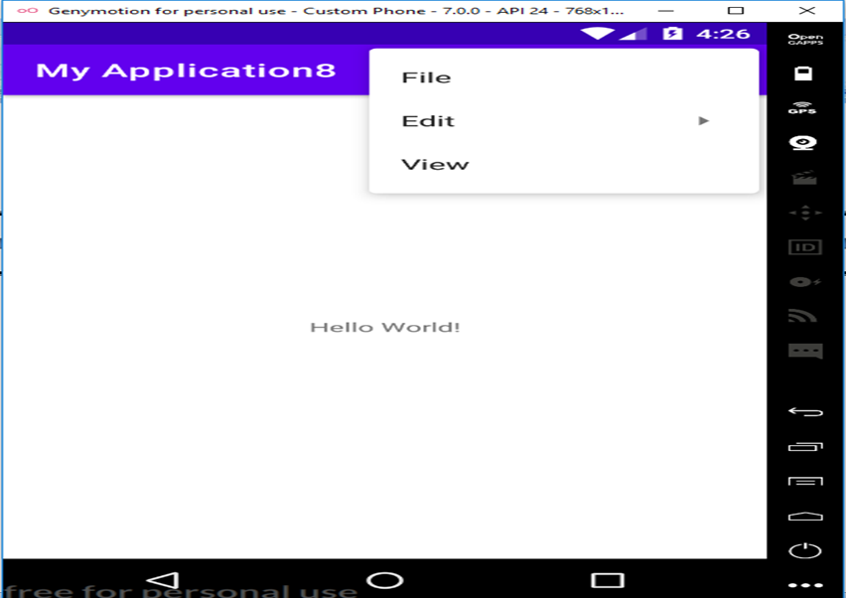**OUTPUT**

**PROGRAM NO:11** **DATE:27-09-2022**

**AIM:** Develop an application that uses ArrayAdapter with ListView.

**PROGRAM CODE:**

**activity.xml**

<?xml version="1.0" encoding="utf-8"?>

<RelativeLayout xmlns:android="http://schemas.android.com/apk/res/android"

xmlns:app="http://schemas.android.com/apk/res-auto"

xmlns:tools="http://schemas.android.com/tools"

android:layout_width="match_parent"

android:layout_height="match_parent"

tools:context=".MainActivity">

<ListView

android:layout_width="wrap_content"

android:layout_height="wrap_content"

android:id="@+id/lv" />

</RelativeLayout>

**mainactivity.java**

package com.example.myapplication10;

import androidx.appcompat.app.AppCompatActivity;

import android.content.Intent;

import android.os.Bundle;

import android.view.View;

import android.widget.AdapterView;

import android.widget.ArrayAdapter;

import android.widget.ListView;

public class MainActivity extends AppCompatActivity {

ListView l;

String [] p={"Apple","Orange","Pineapple"};

@Override

protected void onCreate(Bundle savedInstanceState) {

super.onCreate(savedInstanceState);

setContentView(R.layout.activity_main);

l=(ListView)findViewById(R.id.lv);

ArrayAdapter <String> adapter=new

ArrayAdapter<String>(this,android.R.layout.simple_expandable_list_item_1,p);

l.setAdapter(adapter);

l.setOnItemClickListener(new AdapterView.OnItemClickListener() {

@Override

public void onItemClick(AdapterView<?> adapterView, View view, int i, long l) {

if(i==0){

startActivity(new Intent(MainActivity.this,MainActivity2.class));

}

else if (i==1){

startActivity(new Intent(MainActivity.this,MainActivity2.class));

}

else if (i==2){

startActivity(new Intent(MainActivity.this,MainActivity4.class) );

}

}

});

}

}

**activity2.xml**

<?xml version="1.0" encoding="utf-8"?>

<RelativeLayout xmlns:android="http://schemas.android.com/apk/res/android"

xmlns:app="http://schemas.android.com/apk/res-auto"

xmlns:tools="http://schemas.android.com/tools"

android:layout_width="match_parent"

android:layout_height="match_parent"

tools:context=".MainActivity2">

<TextView

android:layout_width="wrap_content"

android:layout_height="wrap_content"

android:text="Rajendra Prasad, (born December 3, 1884, Zeradei, India—died February 28, 1963, Patna), Indian politician, lawyer, and journalist who was the first president of the Republic of India (1950–62). "/>

</RelativeLayout>

**mainactivity2.java**

package com.example.myapplication10;

import androidx.appcompat.app.AppCompatActivity;

import android.os.Bundle;

public class MainActivity2 extends AppCompatActivity {

@Override

protected void onCreate(Bundle savedInstanceState) {

super.onCreate(savedInstanceState);

setContentView(R.layout.activity_main2);

}

}

**activity3.xml**

<?xml version="1.0" encoding="utf-8"?>

<RelativeLayout xmlns:android="http://schemas.android.com/apk/res/android"

xmlns:app="http://schemas.android.com/apk/res-auto"

xmlns:tools="http://schemas.android.com/tools"

android:layout_width="match_parent"

android:layout_height="match_parent"

tools:context=".MainActivity3">

<TextView

android:layout_width="wrap_content"

android:layout_height="wrap_content"

android:text="S Radhakrishnan was an Indian philosopher and politician who served as the 2nd President of India from 1962 to 1967 and 1st Vice President of India from 1952 to 1962. "/>

</RelativeLayout>

**mainactivity3.java**

package com.example.myapplication10;

import androidx.appcompat.app.AppCompatActivity;

import android.os.Bundle;

public class MainActivity3 extends AppCompatActivity {

@Override

protected void onCreate(Bundle savedInstanceState) {

super.onCreate(savedInstanceState);

setContentView(R.layout.activity_main3);

}

}

**activity4.xml**

<?xml version="1.0" encoding="utf-8"?>

<RelativeLayout xmlns:android="http://schemas.android.com/apk/res/android"

xmlns:app="http://schemas.android.com/apk/res-auto"

xmlns:tools="http://schemas.android.com/tools"

android:layout_width="match_parent"

android:layout_height="match_parent"

tools:context=".MainActivity4">

<TextView

android:layout_width="wrap_content"

android:layout_height="wrap_content"

android:text="Zakir Husain Khan (8 February 1897 – 3 May 1969) known as Dr. Zakir Husain, was an Indian educationist and politician who served as President of India from 13 May 1967 until his death on 3 May 1969."/>

</RelativeLayout>

**mainactivity4.java**

package com.example.myapplication10;

import androidx.appcompat.app.AppCompatActivity;

import android.os.Bundle;

public class MainActivity4 extends AppCompatActivity {

@Override

protected void onCreate(Bundle savedInstanceState) {

super.onCreate(savedInstanceState);

setContentView(R.layout.activity_main4);

}

}

**RESULT:** Program compiled successfully and output verified.

**OUTPUT**

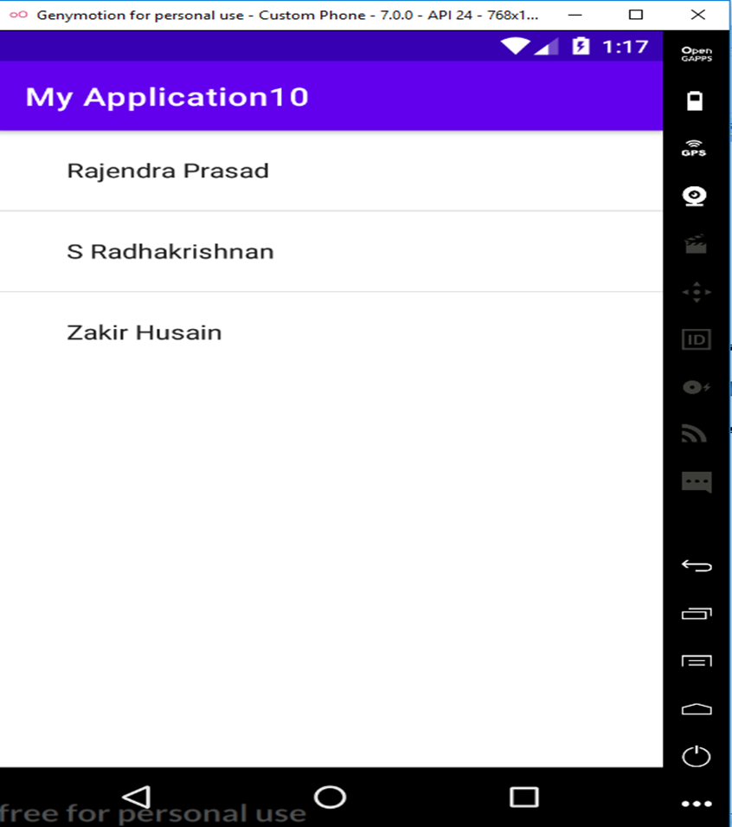

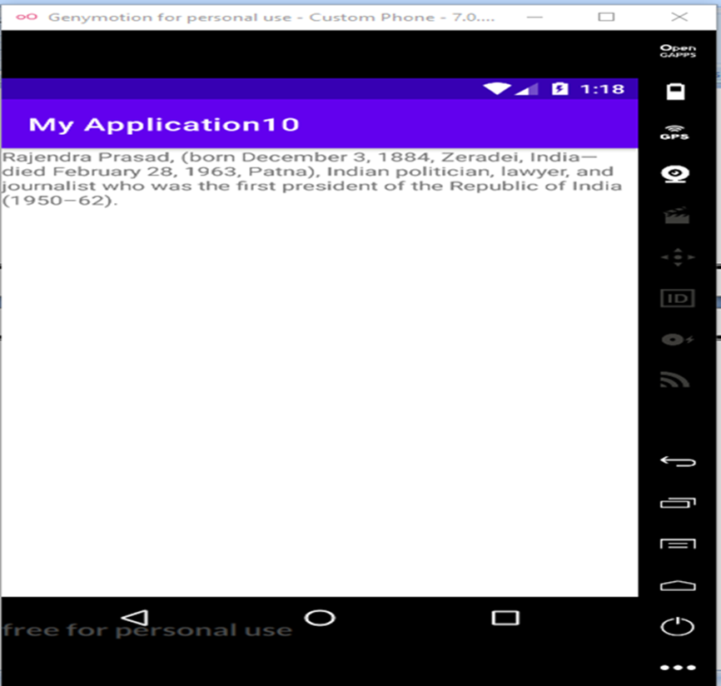

**PROGRAM NO:12 DATE:12-10-2022**

**AIM:** Implement and perform exception handling

**PROGRAM CODE:**

**activity.xml**

<?xml version="1.0" encoding="utf-8"?>

<RelativeLayout xmlns:android="http://schemas.android.com/apk/res/android"

xmlns:app="http://schemas.android.com/apk/res-auto"

xmlns:tools="http://schemas.android.com/tools"

android:layout_width="match_parent"

android:layout_height="match_parent"

tools:context=".MainActivity">

<TextView

android:layout_width="wrap_content"

android:layout_height="wrap_content"

android:id="@+id/tv1" />

</RelativeLayout>

**mainactivity.java**

package com.example.myapplication;

import androidx.appcompat.app.AppCompatActivity;

import android.os.Bundle;

import android.widget.TextView;

import android.widget.Toast;

public class MainActivity extends AppCompatActivity {

TextView tv1;

@Override

protected void onCreate(Bundle savedInstanceState) {

super.onCreate(savedInstanceState);

setContentView(R.layout.activity_main);

try {

tv1.setText("WELCOME");

}

catch (Exception e)

{

Toast.makeText(this,e.getMessage(),Toast.LENGTH_LONG).show();

}

}

}

**RESULT:** Program compiled successfully and output verified.

**OUTPUT**

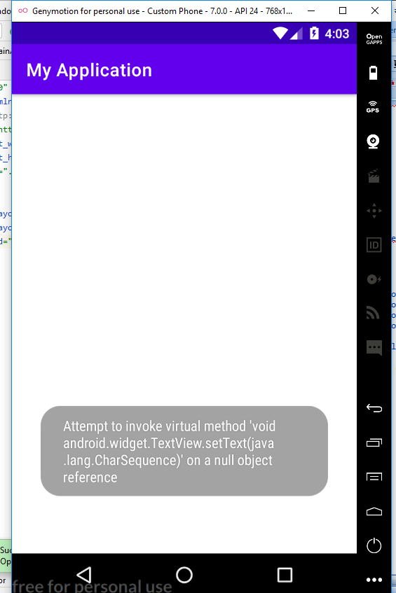

**PROGRAM NO:13 DATE:25-10-2022**

**AIM:** Develop an application that use GridLayout with images and display Alert box on selection.

**PROGRAM CODE:**

**activity.xml**

<?xml version="1.0" encoding="utf-8"?>

<GridLayout xmlns:android="http://schemas.android.com/apk/res/android"

xmlns:app="http://schemas.android.com/apk/res-auto"

xmlns:tools="http://schemas.android.com/tools"

android:layout_width="match_parent"

android:layout_height="match_parent"

tools:context=".MainActivity">

<ImageView

android:layout_width="400dp"

android:layout_height="200dp"

android:id="@+id/im2"

android:src="@drawable/image1"

android:scaleType="centerCrop"

android:layout_row="0"

android:layout_column="0" />

<ImageView

android:layout_width="wrap_content"

android:layout_height="400dp"

android:layout_column="0"

android:scaleType="centerCrop"

android:src="@drawable/image2"

android:id="@+id/im1"

android:layout_row="1"/>

</GridLayout>

**mainactivity.java**

package com.example.myapplication;

import androidx.appcompat.app.AppCompatActivity;

import android.os.Bundle;

import android.view.View;

import android.widget.ImageView;

import android.widget.Toast;

import com.example.myapplication.R;

public class MainActivity extends AppCompatActivity {

ImageView image1,image2;

@Override

protected void onCreate(Bundle savedInstanceState) {

super.onCreate(savedInstanceState);

setContentView(R.layout.activity_main);

image1=findViewById(R.id.im1);

image2=findViewById(R.id.im2);

image1.setOnClickListener(new View.OnClickListener() {

@Override

public void onClick(View view) {

Toast.makeText(getApplicationContext(),"Bird",Toast.LENGTH_LONG).show();

}

});

image2.setOnClickListener(new View.OnClickListener() {

@Override

public void onClick(View view) {

Toast.makeText(getApplicationContext(),"Nature",Toast.LENGTH_LONG).show();

});

}

}

**RESULT:** Program compiled successfully and output verified.

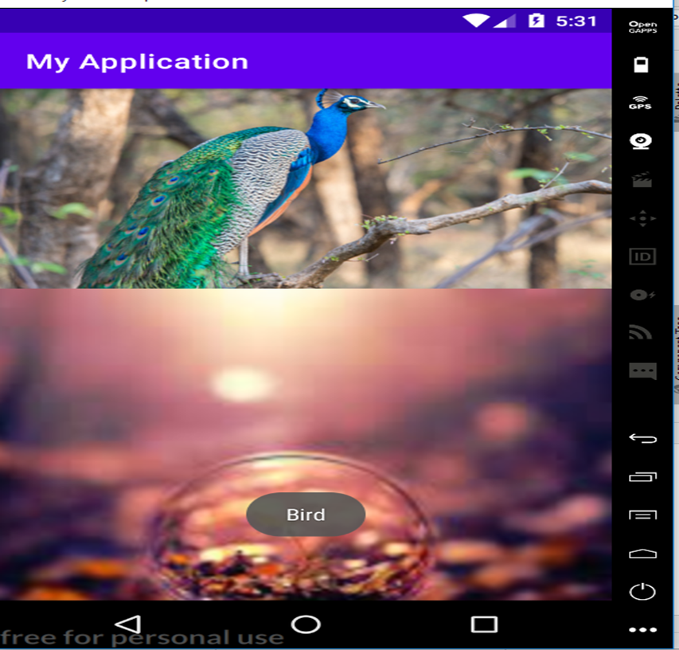**OUTPUT**

**PROGRAM NO:14 DATE:28-10-2022**

**AIM:** Develop an application that implements Spinner component and perform event handling.

**PROGRAM CODE:**

**activity.xml**

<?xml version="1.0" encoding="utf-8"?>

<androidx.constraintlayout.widget.ConstraintLayout xmlns:android="http://schemas.android.com/apk/res/android"

xmlns:app="http://schemas.android.com/apk/res-auto"

xmlns:tools="http://schemas.android.com/tools"

android:layout_width="match_parent"

android:layout_height="match_parent"

tools:context=".MainActivity">

<TextView

android:layout_width="wrap_content"

android:layout_height="wrap_content"

android:textSize="20dp"

android:text="Select Your Nation:"/>

<Spinner

android:id="@+id/spinner"

android:layout_width="149dp"

android:layout_height="40dp"

android:layout_marginBottom="8dp"

android:layout_marginEnd="8dp"

android:layout_marginStart="8dp"

android:layout_marginTop="8dp"

app:layout_constraintBottom_toBottomOf="parent"

app:layout_constraintEnd_toEndOf="parent"

app:layout_constraintHorizontal_bias="0.502"

app:layout_constraintStart_toStartOf="parent"

app:layout_constraintTop_toTopOf="parent"

app:layout_constraintVertical_bias="0.498"

/>

</androidx.constraintlayout.widget.ConstraintLayout>

**mainactivity.java**

package com.example.myapplication;

import androidx.appcompat.app.AppCompatActivity;

import androidx.lifecycle.ViewModelProvider;

import android.os.Bundle;

import android.view.View;

import android.widget.AdapterView;

import android.widget.ArrayAdapter;

import android.widget.Spinner;

import android.widget.Toast;

public class MainActivity extends AppCompatActivity implements AdapterView.OnItemSelectedListener {

String[] country={"India","USA","China","Japan","Other"};

@Override

protected void onCreate(Bundle savedInstanceState) {

super.onCreate(savedInstanceState);

setContentView(R.layout.activity_main);

Spinner spin=(Spinner) findViewById(R.id.spinner);

spin.setOnItemSelectedListener(this);

ArrayAdapter aa =new ArrayAdapter(this,android.R.layout.simple_spinner_item,country);

aa.setDropDownViewResource(android.R.layout.simple_spinner_dropdown_item);

spin.setAdapter(aa);

}

@Override

public void onItemSelected(AdapterView<?> arg0, View arg1, int position, long id) {

Toast.makeText(getApplicationContext(),country[position] , Toast.LENGTH_LONG).show();

/* Intent i=new Intent(getApplicationContext(),MainActivity2.class);

startActivity(i);*/

}

@Override

public void onNothingSelected(AdapterView<?> adapterView) {

// TODO Auto-generated method stub

}

}

**RESULT:** Program compiled successfully and output verified.

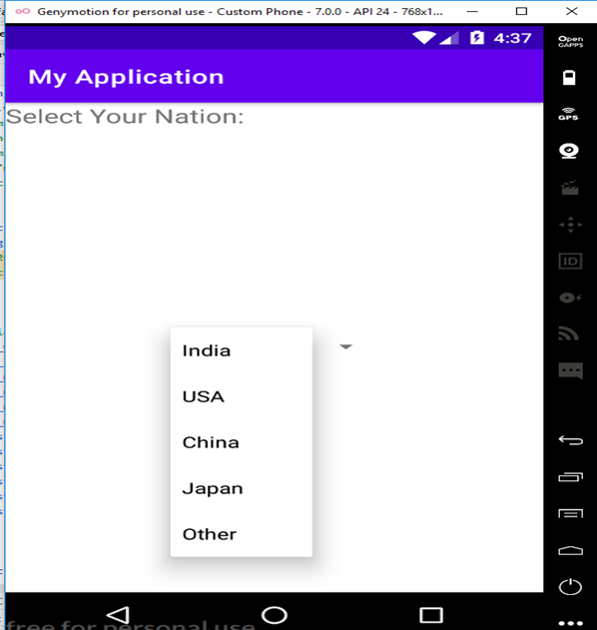**OUTPUT**

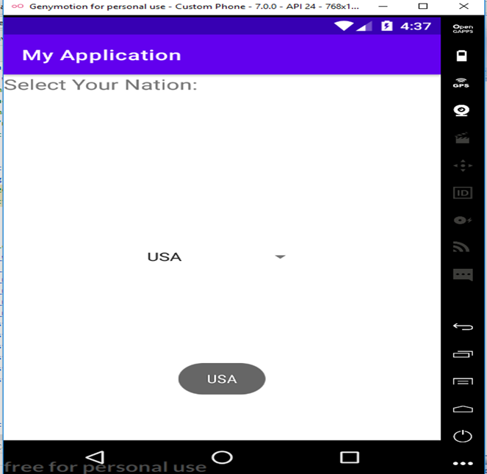

**PROGRAM NO:15 DATE:04-11-2022**

**AIM:** Implement Navigation drawer.

**PROGRAM CODE:**

**activity.xml**

<?xml version="1.0" encoding="utf-8"?>

<androidx.drawerlayout.widget.DrawerLayout

xmlns:android="http://schemas.android.com/apk/res/android"

xmlns:app="http://schemas.android.com/apk/res-auto"

xmlns:tools="http://schemas.android.com/tools"

android:id="@+id/my_drawer_layout"

android:layout_width="match_parent"

android:layout_height="match_parent"

tools:context=".MainActivity"

tools:ignore="HardcodedText">

<LinearLayout

android:layout_width="match_parent"

android:layout_height="match_parent">

<TextView

android:layout_width="match_parent"

android:layout_height="wrap_content"

android:layout_marginTop="128dp"

android:gravity="center"

android:text="NAVIGATION"

android:textSize="18sp" />

</LinearLayout>

<!-- this the navigation view which draws and shows the navigation drawer -->

<!-- include the menu created in the menu folder -->

<com.google.android.material.navigation.NavigationView

android:layout_width="wrap_content"

android:layout_height="match_parent"

android:layout_gravity="start"

app:menu="@menu/navigation_menu" />

</androidx.drawerlayout.widget.DrawerLayout>

**String.xml**

<resources>

<string name="app_name">My Application</string>

<string name="nav_open">Open</string>

<string name="nav_close">Close</string>

</resources>

**Navigation_menu.xml**

<?xml version="1.0" encoding="utf-8"?>

<menu xmlns:android="http://schemas.android.com/apk/res/android">

xmlns:tools="http://schemas.android.com/tools"

tools:ignore="HardcodedText">

<item

android:id="@+id/nav_account"

android:title="My Account" />

<item

android:id="@+id/nav_settings"

android:title="Settings" />

<item

android:id="@+id/nav_logout"

android:title="Logout" />

</menu>

**Mainactivity.java**

package com.example.myapplication;

import androidx.annotation.NonNull;

import androidx.appcompat.app.ActionBarDrawerToggle;

import androidx.appcompat.app.AppCompatActivity;

import androidx.drawerlayout.widget.DrawerLayout;

import android.os.Bundle;

import android.view.MenuItem;

public class MainActivity extends AppCompatActivity {

public DrawerLayout drawerLayout;

public ActionBarDrawerToggle actionBarDrawerToggle;

@Override

protected void onCreate(Bundle savedInstanceState) {

super.onCreate(savedInstanceState);

setContentView(R.layout.activity_main);

drawerLayout = findViewById(R.id.my_drawer_layout);

actionBarDrawerToggle = new ActionBarDrawerToggle(this, drawerLayout, R.string.nav_open, R.string.nav_close);

// pass the Open and Close toggle for the drawer layout listener

// to toggle the button

drawerLayout.addDrawerListener(actionBarDrawerToggle);

actionBarDrawerToggle.syncState();

// to make the Navigation drawer icon always appear on the action bar

getSupportActionBar().setDisplayHomeAsUpEnabled(true);

}

// override the onOptionsItemSelected()

// function to implement

// the item click listener callback

// to open and close the navigation

// drawer when the icon is clicked

@Override

public boolean onOptionsItemSelected(@NonNull MenuItem item) {

if (actionBarDrawerToggle.onOptionsItemSelected(item)) {

return true;

}

return super.onOptionsItemSelected(item);

}

}

**RESULT:** Program compiled successfully and output verified.

**OUTPUT**

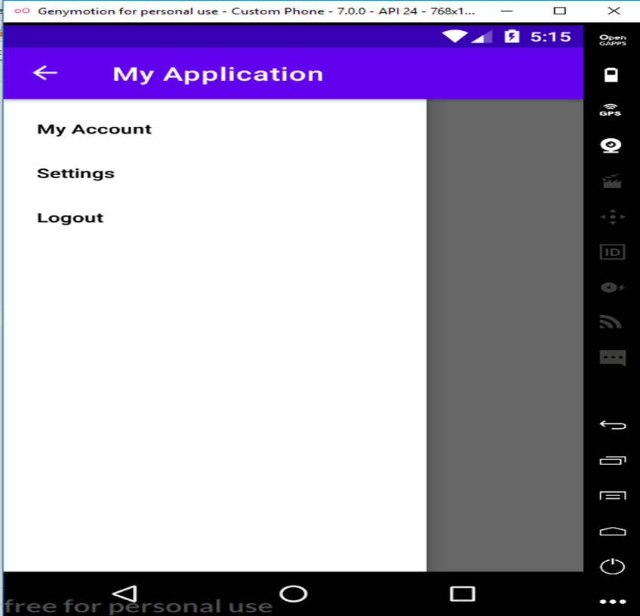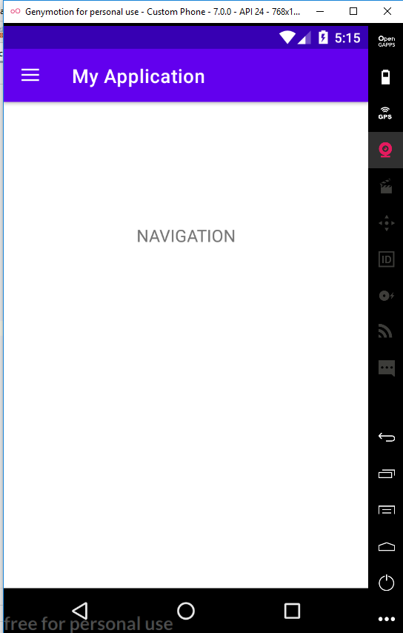

**PROGRAM NO:16 DATE:11-11-2022**

**AIM:** Create database using SQLite and perform INSERT , SELECT , UPDATE and DELETE on SQLite database.

**PROGRAM CODE:**

**activity.xml**

<?xml version="1.0" encoding="utf-8"?>

<RelativeLayout xmlns:android="http://schemas.android.com/apk/res/android"

xmlns:app="http://schemas.android.com/apk/res-auto"

xmlns:tools="http://schemas.android.com/tools"

android:layout_width="match_parent"

android:layout_height="match_parent"

tools:context=".MainActivity"

android:padding="10dp"

>

<TextView

android:layout_width="match_parent"

android:layout_height="wrap_content"

android:text="Please enter the details below:"

android:textSize="24dp"

android:id="@+id/title"

/>

<EditText

android:layout_width="match_parent"

android:layout_height="wrap_content"

android:id="@+id/edt1"

android:hint="Name"

android:textSize="24dp"

android:inputType="textPersonName"

android:layout_below="@+id/title"

/>

<EditText

android:layout_width="match_parent"

android:layout_height="wrap_content"

android:id="@+id/edt2"

android:hint="Contact"

android:textSize="24dp"

android:inputType="number"

android:layout_below="@+id/edt1"

/>

<EditText

android:layout_width="match_parent"

android:layout_height="wrap_content"

android:id="@+id/edt3"

android:hint="DOB"

android:textSize="24dp"

android:inputType="number"

android:layout_below="@+id/edt2"

/>

<Button

android:layout_width="wrap_content"

android:layout_height="wrap_content"

android:id="@+id/b1"

android:text="INSERT "

android:textSize="24dp"

android:layout_below="@+id/edt3"

/>

<Button

android:layout_width="wrap_content"

android:layout_height="wrap_content"

android:id="@+id/b2"

android:text="UPDATE "

android:textSize="24dp"

android:layout_below="@+id/b1"/>

<Button

android:layout_width="wrap_content"

android:layout_height="wrap_content"

android:id="@+id/b3"

android:text="DELETE "

android:textSize="24dp"

android:layout_below="@+id/b2"

/>

<Button

android:layout_width="wrap_content"

android:layout_height="wrap_content"

android:id="@+id/b4"

android:text="VIEW "

android:textSize="24dp"

android:layout_below="@+id/b3"

/>

</RelativeLayout>

**DBHelper.java**

package com.example.myapplication;

import android.content.ContentValues;

import android.content.Context;

import android.database.Cursor;

import android.database.sqlite.SQLiteDatabase;

import android.database.sqlite.SQLiteOpenHelper;

import androidx.annotation.Nullable;

public class DBHelper extends SQLiteOpenHelper {

public DBHelper(@Nullable Context context){

super(context, "userdata.db",null,1);

}

@Override

public void onCreate(SQLiteDatabase DB) {

DB.execSQL("create Table userdetails(name TEXT primary key, contact TEXT , dob TEXT)");

}

@Override

public void onUpgrade(SQLiteDatabase DB, int i, int i1) {

DB.execSQL("drop Table if exists userdetails");

}

public Boolean insertData(String name, String contact, String dob)

{

SQLiteDatabase DB= this.getWritableDatabase();

ContentValues contentValues=new ContentValues();

contentValues.put("name",name);

contentValues.put("contact",contact);

contentValues.put("dob",dob);

long result=DB.insert("userdetails",null,contentValues);

if(result==-1)

return false;

else

return true;

}

public Boolean updateData(String name, String contact, String dob)

{

SQLiteDatabase DB= this.getWritableDatabase();

ContentValues contentValues=new ContentValues();

contentValues.put("contact",contact);

contentValues.put("dob",dob);

Cursor cursor=DB.rawQuery("select * from userdetails where name=?", new String[] {name});

if(cursor.getCount()>0) {

long result = DB.update("userdetails", contentValues, "name=?", new String[]{name});

if (result == -1)

return false;

else

return true;

}

else

{

return false;

}

}

public Boolean deleteData(String name)

{

SQLiteDatabase DB= this.getWritableDatabase();

Cursor cursor=DB.rawQuery("select * from userdetails where name=?", new String[] {name});

if(cursor.getCount()>0) {

long result = DB.delete("userdetails", "name=?", new String[]{name});

if (result == -1)

return false;

else

return true;

}

else

{

return false;

}

}

public Cursor getData()

{

SQLiteDatabase DB= this.getWritableDatabase();

Cursor cursor=DB.rawQuery("select * from userdetails",null);

return cursor;

}

}

**Mainactivity.java**

package com.example.myapplication;

import androidx.appcompat.app.AlertDialog;

import androidx.appcompat.app.AppCompatActivity;

import android.database.Cursor;

import android.os.Bundle;

import android.provider.ContactsContract;

import android.view.View;

import android.widget.Button;

import android.widget.EditText;

import android.widget.Toast;

public class MainActivity extends AppCompatActivity {

EditText edt1,edt2,edt3;

Button Insert,Update,Delete,View;

DBHelper db;

@Override

protected void onCreate(Bundle savedInstanceState) {

super.onCreate(savedInstanceState);

setContentView(R.layout.activity_main);

edt1=findViewById(R.id.edt1);

edt2=findViewById(R.id.edt2);

edt3=findViewById(R.id.edt3);

Insert =findViewById(R.id.b1);

Update = findViewById(R.id.b2);

Delete = findViewById(R.id.b3);

View =findViewById(R.id.b4);

db=new DBHelper(this);

Insert.setOnClickListener(new View.OnClickListener() {

@Override

public void onClick(android.view.View view){

String name= edt1.getText().toString();

String contact=edt2.getText().toString();

String dob= edt3.getText().toString();

boolean checkInsertData=db.insertData(name,contact,dob);

if (checkInsertData==true)

Toast.makeText(MainActivity.this,"New entry inserted",Toast.LENGTH_LONG).show();

else

Toast.makeText(MainActivity.this,"New entry Not inserted",Toast.LENGTH_LONG).show();

}

});

Update.setOnClickListener(new View.OnClickListener() {

@Override

public void onClick(android.view.View view) {

String name= edt1.getText().toString();

String contact=edt2.getText().toString();

String dob= edt3.getText().toString();

boolean checkUpdateData=db.updateData(name,contact,dob);

if(checkUpdateData==true)

Toast.makeText(MainActivity.this,"Entry updated",Toast.LENGTH_LONG).show();

else

Toast.makeText(MainActivity.this,"Entry Not Updated",Toast.LENGTH_LONG).show();

}

});

Delete.setOnClickListener(new View.OnClickListener() {

@Override

public void onClick(android.view.View view) {

String name= edt1.getText().toString();

boolean checkDeleteData= db.deleteData(name);

if(checkDeleteData==true)

Toast.makeText(MainActivity.this,"Entry deleted",Toast.LENGTH_LONG).show();

else

Toast.makeText(MainActivity.this,"Entry Not deleted",Toast.LENGTH_LONG).show();

}

});

View.setOnClickListener(new View.OnClickListener() {

@Override

public void onClick(android.view.View view) {

Cursor res = db.getData();

if (res.getCount() == 0) {

Toast.makeText(MainActivity.this, "No entry exists", Toast.LENGTH_LONG).show();

return;

}

StringBuffer buffer = new StringBuffer();

while (res.moveToNext()) {

buffer.append("name:" + res.getString(0) + "\n");

buffer.append("contact:" + res.getString(1) + "\n");

buffer.append("data of birth:" + res.getString(2) + "\n\n\n\n\n");

}

AlertDialog.Builder builder=new AlertDialog.Builder(MainActivity.this);

builder.setCancelable(true);

builder.setTitle("User Enteries");

builder.setMessage(buffer.toString());

builder.show();

}

});

}

}

**RESULT:** Program compiled successfully and output verified.

**OUTPUT**

